//Programmer Name: Sharvil Prabhudesai 20co41

//Program title : FCFS

#include <stdio.h>

#include<stdlib.h>

int i,n,a[50],head;

void input(){

printf("Enter the size of the request array : ");

scanf("%d",&n);

printf("Enter the Request array : \n");

for(i=0;i<n;i++){

scanf("%d",&a[i]);

}

printf("\nEnter the Current Head Position : ");

scanf("%d",&head);

printf("\n");

}

void FCFS()

{

int TotalHeadMovement = 0;

int distance, cur_track;

for (i = 0; i < n; i++) {

cur_track = a[i];

distance = abs(cur_track - head);

TotalHeadMovement = TotalHeadMovement + distance;

head = cur_track;

}

printf("Total Disk Head Movement is : %d \n",TotalHeadMovement);

printf("Sequence in which request is scheduled is : \n");

for (int i = 0; i < n; i++) {

printf("%d ",a[i]);

}

}

int main()

{

printf("\nFCFS Disk Scheduling \n\n");

input();

FCFS();

return 0;

}

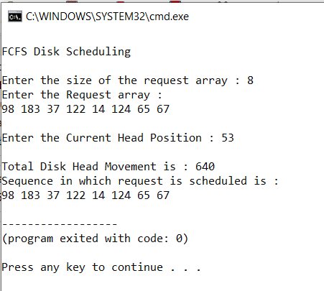

//Programmer Name: Sharvil Prabhudesai 20co41

//Program title : SSTF

#include <stdio.h>

#include <stdlib.h>

int i,n,a[50],head;

void input(){

printf("Enter the size of the request array : ");

scanf("%d",&n);

printf("Enter the Request array : \n");

for(i=0;i<n;i++){

scanf("%d",&a[i]);

}

printf("\nEnter the Current Head Position : ");

scanf("%d",&head);

printf("\n");

}

void SSTF(){

int TotalHeadMoment = 0, count = 0;

printf("Sequence in which request is scheduled is : ");

while (count != n){

int min = 1000, d, index;

for (i = 0; i < n; i++){

d = abs(a[i] - head);

if (min > d){

min = d;

index = i;

}

}

printf("%d ", a[index]);

TotalHeadMoment = TotalHeadMoment + min;

head = a[index];

a[index] = 9999;

count++;

}

printf("\n\nTotal head movement is %d \n", TotalHeadMoment);

}

int main() {

printf("\nSSTF Disk Scheduling \n\n");

input();

SSTF();

return 0;

}

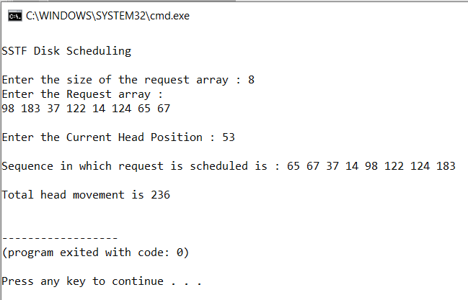

//Programmer Name: Sharvil Prabhudesai 20co41

//Program title : SCAN

#include<stdio.h>

#include<stdlib.h>

int array[25],n,head,i,j,k,TotalHeadMovement=0, maxrange,difference,temp,array1[20],array2[20],temp1=0,temp2=0;

void input(){

printf("Enter the maximum range of Disk: ");

scanf("%d",&maxrange);

printf("Enter the number of array requests: ");

scanf("%d",&n);

printf("Enter the initial head position: ");

scanf("%d",&head);

printf("Sequence in which request is scheduled is : ");

for(i=1;i<=n;i++)

{

scanf("%d",&temp);

if(temp>head) {

array1[temp1]=temp; //temp1 is the index variable of array1[]

temp1++; //incrementing temp1

}

else {

array2[temp2]=temp; //temp2 is the index variable of array2[]

temp2++;

}

}

}

void SCAN() {

for(i=0;i<temp1-1;i++) {

for(j=i+1;j<temp1;j++) {

if(array1[i]>array1[j]) {

temp=array1[i];

array1[i]=array1[j];

array1[j]=temp;

}

}

}

for(i=0;i<temp2-1;i++) {

for(j=i+1;j<temp2;j++) {

if(array2[i]<array2[j]) {

temp=array2[i];

array2[i]=array2[j];

array2[j]=temp;

}

}

}

for(i=1,j=0;j<temp1;i++,j++) {

array[i]=array1[j];

}

array[i]=maxrange;

for(i=temp1+2,j=0;j<temp2;i++,j++){

array[i]=array2[j];

}

array[i]=0;

array[0]=head;

for(j=0; j<=n; j++) {

difference = abs(array[j+1]-array[j]);

TotalHeadMovement = TotalHeadMovement + difference;

}

printf("Sequence in which request is scheduled is : ");

for(j=1; j<=n+1; j++){

printf("%d ", array[j]);

}

printf("\nTotal Disk Head Movement : %d \n", TotalHeadMovement);

}

int main()

{

printf("\nSCAN Disk Scheduling \n\n");

input();

SCAN();

return 0;

}

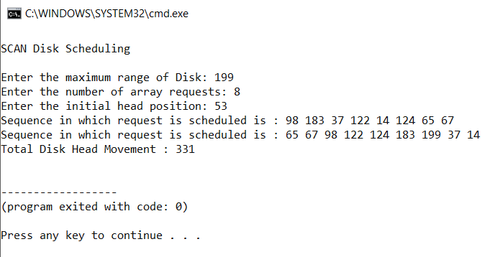

//Programmer Name: Sharvil Prabhudesai 20co41

//Program title : CSCAN

#include<stdio.h>

#include<stdlib.h>

int array[25],n,head,i,j,k,TotalHeadMovement=0, maxrange,difference,temp,array1[20],array2[20],temp1=0,temp2=0;

void input(){

printf("Enter the maximum range of Disk: ");

scanf("%d",&maxrange);

printf("Enter the number of array requests: ");

scanf("%d",&n);

printf("Enter the initial head position: ");

scanf("%d",&head);

printf("Sequence in which request is scheduled is : ");

for(i=1;i<=n;i++) {

scanf("%d",&temp);

if(temp>head) {

array1[temp1]=temp; //temp1 is the index variable of array1[]

temp1++; //incrementing temp1

}

else {

array2[temp2]=temp; //temp2 is the index variable of array2[]

temp2++;

}

}

}

void CSCAN() {

for(i=0;i<temp1-1;i++) {

for(j=i+1;j<temp1;j++) {

if(array1[i]>array1[j]) {

temp=array1[i];

array1[i]=array1[j];

array1[j]=temp;

}

}

}

for(i=0;i<temp2-1;i++) {

for(j=i+1;j<temp2;j++) {

if(array2[i]>array2[j]) {

temp=array2[i];

array2[i]=array2[j];

array2[j]=temp;

}

}

}

for(i=1,j=0;j<temp1;i++,j++) {

array[i]=array1[j];

}

array[i]=maxrange;

array1[i+1]=0;

for(i=temp1+3,j=0;j<temp2;i++,j++) {

array[i]=array2[j];

}

array[0]=head;

for(j=0; j<=n+1; j++) {

difference = abs(array[j+1]-array[j]);

TotalHeadMovement = TotalHeadMovement + difference;

}

printf("Sequence in which request is scheduled is : ");

for(j=1; j<=n+2; j++) {

printf("%d ", array[j]);

}

printf("\nTotal Disk Head Movement : %d \n", TotalHeadMovement);

}

int main()

{

printf("\nCSCAN Disk Scheduling \n\n");

input();

CSCAN();

return 0;

}

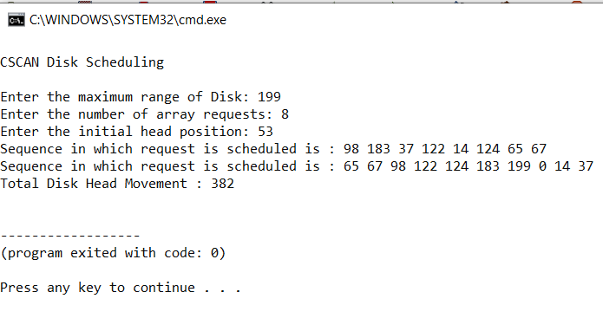

//Programmer Name: Sharvil Prabhudesai 20co41

//Program title : LOOK

#include<stdio.h>

#include<stdlib.h>

int array[25],n,head,i,j,k,TotalHeadMovement=0, maxrange,difference,temp,array1[20],array2[20],temp1=0,temp2=0;

void input(){.

printf("Enter the maximum range of Disk: ");

scanf("%d",&maxrange);

printf("Enter the number of array requests: ");

scanf("%d",&n);

printf("Enter the initial head position: ");

scanf("%d",&head);

printf("Sequence in which request is scheduled is : ");

for(i=1;i<=n;i++) {

scanf("%d",&temp);

if(temp>head) {

array1[temp1]=temp; //temp1 is the index variable of array1[]

temp1++; //incrementing temp1

}

else {

array2[temp2]=temp; //temp2 is the index variable of array2[]

temp2++;

}

}

}

void LOOK(){

for(i=0;i<temp1-1;i++) {

for(j=i+1;j<temp1;j++) {

if(array1[i]>array1[j]) {

temp=array1[i];

array1[i]=array1[j];

array1[j]=temp;

}

}

}

for(i=0;i<temp2-1;i++) {

for(j=i+1;j<temp2;j++) {

if(array2[i]<array2[j]) {

temp=array2[i];

array2[i]=array2[j];

array2[j]=temp;

}

}

}

for(i=1,j=0;j<temp1;i++,j++) {

array[i]=array1[j];

}

for(i=temp1+1,j=0;j<temp2;i++,j++){

array[i]=array2[j];

}

array[i]=0;

array[0]=head;

for(j=0; j<n; j++) {

difference = abs(array[j+1]-array[j]);

TotalHeadMovement = TotalHeadMovement + difference;

}

printf("Sequence in which request is scheduled is : ");

for(j=1; j<=n; j++) {

printf("%d ", array[j]);

}

printf("\nTotal Disk Head Movement : %d \n", TotalHeadMovement);

}

int main() {

printf("\nLOOK Disk Scheduling \n\n");

input();

LOOK();

return 0;

}

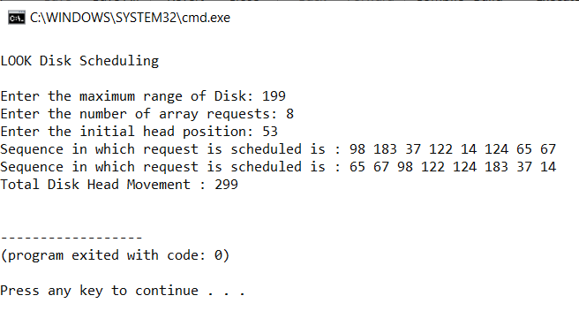

//Programmer Name: Sharvil Prabhudesai 20co41

//Program title : CLOOK

#include<stdio.h>

#include<stdlib.h>

int array[25],n,head,i,j,k,TotalHeadMovement=0, maxrange,difference,temp,array1[20],array2[20],temp1=0,temp2=0;

void input(){

printf("Enter the maximum range of Disk: ");

scanf("%d",&maxrange);

printf("Enter the number of array requests: ");

scanf("%d",&n);

printf("Enter the initial head position: ");

scanf("%d",&head);

printf("Sequence in which request is scheduled is : ");

for(i=1;i<=n;i++) {

scanf("%d",&temp);

if(temp>head) {

array1[temp1]=temp; //temp1 is the index variable of array1[]

temp1++; //incrementing temp1

}

else {

array2[temp2]=temp; //temp2 is the index variable of array2[]

temp2++;

}

}

}

void CLOOK(){

for(i=0;i<temp1-1;i++) {

for(j=i+1;j<temp1;j++) {

if(array1[i]>array1[j]) {

temp=array1[i];

array1[i]=array1[j];

array1[j]=temp;

}

}

}

for(i=0;i<temp2-1;i++) {

for(j=i+1;j<temp2;j++) {

if(array2[i]>array2[j]) {

temp=array2[i];

array2[i]=array2[j];

array2[j]=temp;

}

}

}

for(i=1,j=0;j<temp1;i++,j++) {

array[i]=array1[j];

}

for(i=temp1+1,j=0;j<temp2;i++,j++) {

array[i]=array2[j];

}

array[0]=head;

for(j=0; j< n; j++) {

difference = abs(array[j+1]-array[j]);

TotalHeadMovement = TotalHeadMovement + difference;

}

printf("Sequence in which request is scheduled is : ");

for(j=1; j<=n; j++) {

printf("%d ", array[j]);

}

printf("\nTotal Disk Head Movement : %d \n", TotalHeadMovement);

}

int main()

{

printf("\nCLOOK Disk Scheduling \n\n");

input();

CLOOK();

return 0;

}

